Annual Meeting 2026 ICW Contacts
San Juan, PR
November 8-11, 2026

Hotel Information
Headquarters Hotel
Sheraton Puerto Rico
Contact: William Rosa, Sr. Meetings & Events Manager at Sheraton Puerto Rico Hotel & Casino
William.Rosa@Sheraton.com, 787.664.0297
Address: 200 Convention Blvd, San Juan, PR 00907
Phone: (787) 993-3500
Website: Sheraton PR Website

Aloft San Juan
Contact: Frances Guzmán, Sales Manager
frances.guzman@alofthotels.com, 787.979.0186
Address: 300 Convention Blvd, San Juan, PR 00907
Phone: (787) 977-6000
Website: Aloft San Juan Website
Distance to Sheraton: 3–4 minute walk

Hyatt Place San Juan
Contact: Gabriela Baldaguez, Dual Sales Manager, Hyatt Place & Hyatt House San Juan
Address: 580 Av. Fernández Juncos, San Juan, PR 00907
Phone: (787) 721-3000
Website: Hyatt Place San Juan Website
Distance to Sheraton: 2–3-minute walk

Hyatt House San Juan
Contact: Gabriela Baldaguez, Dual Sales Manager, Hyatt Place & Hyatt House San Juan
gabriela.baldaguez@hyatt.com, 787.539.9994
Address: 615 Av. Fernández Juncos, San Juan, PR 00907
Phone: (787) 977-5000
Website: Hyatt House San Juan Website
Distance to Sheraton: 2–3 minute walk

Hilton Garden Inn San Juan Condado
Contact: Liana Basora, Events Service Manager at Condado Plaza & Hilton Garden Inn
liana.basora@hilton.com, 787.307.9645
Address: 886 Ashford Ave, San Juan, PR 00907
Phone: (787) 723-8000
Website: Hilton Garden Inn San Juan Website
Distance to Sheraton: Uber, not walkable 5-10 mins

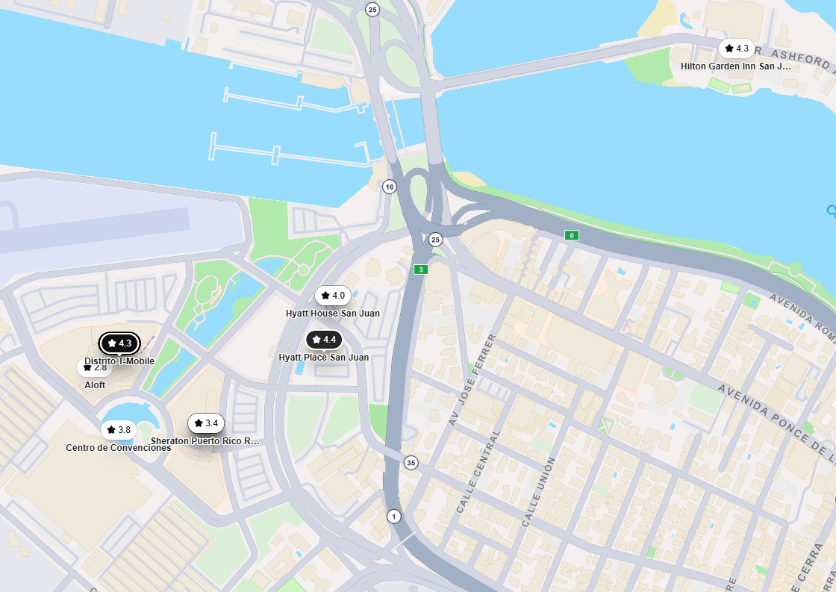

Destination Management Services
Group Services Inc., Puerto Rico
Berk Tanal, berk@gsipuertorico.com
Destination Management Company (DMC) can provide:

- Transportation
- Venue sourcing
- Event décor and design
- Staffing support
- Entertainment
- Tours and unique local experiences
- Team-building activities
- Off-site events
- Restaurant recommendations
- VIP and guest services
- On-site logistics and event management
- Local expertise and vendor coordination

Providing truly unique and customized experiences for conventions, meetings and incentive groups since 1992, GSI is your trusted DMC Partner. We offer an array of services ranging from event design and décor, to inspiring team-building events, land and marine tours, transportation, and so much more. GSI consistently delivers your company outstanding Destination Management Services and experience for your next event. Consistency, trust and reliability are key. GSI has built a reputation as the most trusted DMC in Puerto Rico. We invite you to Choose Puerto Rico and Choose GSI.

Other Venues Close to Sheraton Within Walking Distance

Puerto Rico Convention Center

Gianni Agostini

Senior Sales Manager

gagostini@prconvention.com, 787.463.1228

Coca-Cola Music Hall

300 Convention Boulevard, San Juan, San Juan, PR

https://distritot-mobile.com/coca-cola-music-hall
Beatriz Colón Trillo, Partnership Sales & Services Manager
The Music Hall has three levels and capacity for up to 4,000 people. Their flexible capacities, unrivaled sightlines via tiered rows, superior sound, and lights, including a large dance floor and full-service bars conveniently placed around the venue maximize flow, efficiency, and patron experience.

Distrito T-Mobile
300 Convention Blvd, San Juan, Puerto Rico
https://www.discoverpuertorico.com/profile/distrito-t-mobile/12787
Nidymar Boscana Pérez, Sales Manager
787.237.2966
At DISTRITO T-Mobile, you'll find seven unique dining experiences, with each restaurant offering an unforgettable gastronomic adventure. After you've enjoyed a delicious meal, head to one of DISTRITO T-Mobile's entertainment options, you can choose to go ziplining, catch a movie, or even enjoy a concert at the Coca-Cola Music Hall.

Private Group Dining Options Near Sheraton Puerto Rico
This list highlights restaurants within walking distance of the Sheraton Puerto Rico that are suitable for private group dining, committee dinners, sponsor events, and networking receptions. Some recommended uses:
- Executive/Board Dinner: Mutuo or La Central
- Committee Dinners: Metropol or Sazón Cocina Criolla
- Sponsor Dinner: La Central
- Networking Reception: Arena Medalla or Barullo
- Casual Networking: El Beer Garden or Lupe Reyes

Metropol Restaurant
Phone: (787) 993-3588
Website: https://www.metropolrestaurant.com
Location: Inside Sheraton
Walking Time: <1 min
Cuisine: Puerto Rican & Cuban
Description: Popular convention restaurant serving authentic Puerto Rican and Cuban cuisine including mofongo, seafood, roast pork, steaks and local specialties. Excellent for conference groups.
Private Dining: Private rooms, semi-private space, customized menus, buffet or plated service.
Estimated Capacity: 15-100+

Mutuo Sabor Nikkei
Website: https://www.marriott.com
Phone: (787) 993-3500Location: Inside Sheraton
Walking Time: <1 min
Cuisine: Japanese-Peruvian (Nikkei)
Description: Upscale signature restaurant blending Japanese and Peruvian flavors with sushi, ceviche, seafood and premium cocktails.
Private Dining: Semi-private dining, tasting menus, cocktail receptions.
Estimated Capacity: 15-50

Choices Urban Bistro
Website: https://www.marriott.com
Phone: (787) 993-3500
Location: Inside Sheraton
Walking Time: <1 min
Cuisine: International
Description: Hotel restaurant ideal for breakfasts and lunches and available for private functions.
Private Dining: Private breakfasts, working lunches.
Estimated Capacity: 20-60

La Central by Mario Pagán
Website: https://www.distritot-mobile.com
Phone: (787) 592-6817
Location: 0.4 miles
Walking Time: 8 min
Cuisine: Modern Puerto Rican Steakhouse
Description: Celebrity Chef Mario Pagán's restaurant featuring wood-fired steaks, seafood, local ingredients and an extensive wine list.
Private Dining: Private dining room, wine room, buyouts, customized menus.
Estimated Capacity: 20-100

Sazón Cocina Criolla
Website: https://www.distritot-mobile.com
Phone: (787) 688-1919
Location: 0.5 miles
Walking Time: 8-10 min
Cuisine: Puerto Rican
Description: Authentic Puerto Rican cuisine in an upscale setting. Great introduction to island flavors.
Private Dining: Private room, prix fixe menus, large group seating.
Estimated Capacity: 30-60

Barullo Taberna Española
Website: https://www.distritot-mobile.com
Phone: (939) 439-4584
Location: 0.5 miles
Walking Time: 8-10 min
Cuisine: Spanish Tapas
Description: Lively Spanish restaurant known for tapas, paella, sangria and wines.
Private Dining: Private dining, communal tables, receptions.
Estimated Capacity: 30-80

Lupe Reyes
Website: https://www.distritot-mobile.com
Phone: (787) 401-8860
Location: 0.5 miles
Walking Time: 8-10 min
Cuisine: Mexican
Description: Colorful casual restaurant with tacos, fajitas, margaritas and tequila.
Private Dining: Large group tables and group menus.
Estimated Capacity: 30-70

Arena Medalla
Website: https://www.distritot-mobile.com
Phone: (787) 592-6196
Location: 0.5 miles
Walking Time: 8-10 min
Cuisine: Puerto Rican & American
Description: Large entertainment venue with multiple dining spaces and live entertainment.
Private Dining: Private rooms, buyouts, receptions.
Estimated Capacity: 50-300+

El Beer Garden
Website: https://www.distritot-mobile.com
Phone: N/A
Location: 0.3 miles
Walking Time: 5-6 min
Cuisine: Pizza & Beer Garden
Description: Outdoor venue with pizza, burgers, local beer and casual networking atmosphere.
Private Dining: Outdoor receptions and buyouts.
Estimated Capacity: 40-150

Club Náutico de San Juan
Website: https://clubnauticodesanjuan.com/V2/
Phone: (787) 722-0177
Distance from Sheraton: Approximately 0.4 miles
Walking Time: 8–10 minutes
Address: 480 Av. Manuel Fernández Juncos, San Juan
Description: Founded in 1925, Club Náutico de San Juan is Puerto Rico's premier yacht club. Located on San Juan Bay, it offers beautiful marina views and has extensive experience hosting weddings, corporate events, receptions, and private dinners. Excellent sunset views over San Juan Bay.
Estimated Capacity: Boardroom: 20–30, Private dining: 40–80, Banquet: 100–200, Cocktail reception: 250+

