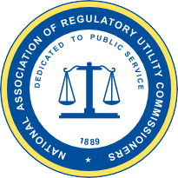

National Association of Regulatory Utility Commissioners


Workforce Development Toolbox: Recruitment Templates and Social Media Engagement Materials

Hyleah O’Quinn, NARUC
September 2022

Disclaimer
This material is based upon work supported by the U.S. Department of Energy, Office of Cybersecurity, Energy Security, and Emergency Response, under Award Number DE-CR0000009.
This report was prepared as an account of work sponsored by an agency of the United States Government. Neither the United States Government nor any agency thereof, nor any of their employees, makes any warranty, express or implied, or assumes any legal liability or responsibility for the accuracy, completeness, or usefulness of any information, apparatus, product, or process disclosed, or represents that its use would not infringe privately owned rights. Reference herein to any specific commercial product, process, or service by trade name, trademark, manufacturer, or otherwise does not necessarily constitute or imply its endorsement, recommendation, or favoring by the United States Government or any agency thereof. The views and opinions of authors expressed herein do not necessarily state or reflect those of the United States Government or any agency thereof.

Acknowledgments
The author wishes to thank the following individuals for their contributions and interest in the development of this paper:
- Brandi Martin, Jason Pazirandeh, and Mallory Pettis, U.S. Department of Energy, Office of Cybersecurity, Energy Security, and Emergency Response
- Kelly Crandall, Colorado Public Utilities Commission
- Stacy Traxler, Oregon Public Utility Commission
- Malika Davis, and Samantha Hemphill, Delaware Public Service Commission
- Judge Jehmal Hudson, and Whitney Mays, Virginia State Corporation Commission
- Veronica Ung-Kono, Vermont Public Utility Commission

Table of Contents
Disclaimer i
Acknowledgments i
Introduction 3
Recruitment Template: Bi-Fold Brochure 4
Recruitment Template: Tri-Fold Brochure 7
Recruitment Template: Stickers 10
Social Media Engagement: LinkedIn 12
Social Media Engagement: Instagram 15
Social Media Engagement: Twitter 17

Introduction
Public Utility Commissions (PUCs) are amongst other U.S employers that have encountered recruitment and retention challenges when developing a strong and viable workforce. Nationally, PUCs have the goal to establish a qualified and robust workforce while combating labor and talent shortages, increased competition from the private sector, and lack of knowledge around the important work PUCs do.
Commissions perform the difficult act of balancing the need for a well-functioning and healthy utility—such as an electric or gas utility—with the needs of people and businesses for the utility’s services to be safe, reliable, and affordable. Working at a Commission mean thinking deeply about the laws and policies that promote the public interest. And as utilities are called upon to decarbonize and to become more fair and equitable to their customers, Commissions are also called upon to apply new skills and new ways of thinking. Now more than ever, commissioners need skilled, motivated, and confident professionals to assist with navigating emerging challenges within the energy system.
This Workforce Development Toolbox will provide recruitment templates and social media engagement materials that explain the role of PUCs, describe career opportunities, and highlights the benefits of public service. PUCs can tailor each template and material to meet their recruitment needs and use at respective job fairs, online recruiting forums, summits, conferences, etc.

Recruitment Template: Bi-Fold Brochure

Although we live in a digital age where all information to be sought can be found online, having a handout has proven to be an effective tool to support dialogue around a technical subject. This editable bi-fold brochure is meant to be bold, straightforward, and explanatory.
IMPORTANT: Please read through the entire brochure and fill in the appropriate information for your stated in the outline areas before printing. The editable word document can be downloaded here.

DO YOU HAVE THE HEART FOR PUBLIC SERVICE?

Take a significant role in protecting the public interest

The success of the Public Utility Commission (PUC), or depending on the state, Public Service Commission (PSC) relies on dedicated, knowledgeable candidates who works collaboratively as the Commissions regulates the many essential utility services – such as electric power and water - that residents and business rely on every day.
By joining a PUC, you are making a direct impact on valuable areas that affect our quality of life, economic development, clean energy, air quality, energy efficiency program design and funding, critical infrastructure, and public resources.


Check out our state commission’s website
to see which positions are hiring!
Contribute your expertise to an equitable workforce
Chair Andrew Fay
“The energy-specific work sparked my interest in the Commission because how far-reaching the Commission decisions can be. People think about highly regulated industries…but none of those industries work to their highest potential without reliable energy. It’s a core component of almost everything we do.”
Consider working for a
Public Service/ Public Utility Commission!
Florida Public Service Commission
Picture and quote from interview in Public Utilities Fortnightly, May 2022

[insert website here]

…. Commission
Commissions are composed of between three and seven Commissioners that have oversight of all Commission staff-related activities. They also make all determinations and decisions that are brought before the Commission.
When hired at a state commission, you’re considered an expert. As an expert, you’ll work in an advisory role to the Commissioners to enhance their understanding of every issue brought to the Commission. You’ll have a direct influence on the decisions made on behalf of the ratepayers in the state.
PUCs/PSCs are looking for a multitude of different candidates – including accountants, auditors, analysts, engineers, social media relations, planners, attorneys, managers, information technology and consumer specialist/analysts. Internships may also be offered by PUCs/PSC in some states! Commissions offer countless opportunities for professional development and hybrid or telework opportunities (depending on the state).
PUCs and PSCs welcome a variety of education and experience when recruiting qualified candidates. Professional-level Commissions positions generally have minimum education requirements of a bachelor’s or master’s degree from an accredited college or university. Desirable candidates have strong interpersonal skills, superior judgment, and the willingness to foster a sustainable and prosperous economic future for the state.
Dynamic, distinct experience
Commissioner ….
“ … Insert quote from a Commissioner from your state describing the benefits of public service or the impact your work has on the residents of your state ...”
Serve diverse communities across the state
Public Utility Commissions (PUCs) and Public Service Commissions (PSCs) regulate electric, gas, telecommunications, water, and wastewater utilities. Utility commissions ensure utilities provide reasonable, adequate, and efficient service to customers at just prices. Utility regulation takes many forms, including price regulation, resource planning and acquisition, reliability, and quality of service regulations. PUCs typically regulate all investor-owned utilities (IOUs) in their state. Municipal and cooperative utilities are often exempted from PUC regulation or have limited regulation.
Safety, reliability, and service. Reaching nationally.

Recruitment Template: Tri-Fold Brochure

This editable tri-fold brochure is meant to provide the technical information that might not be conveyed during an informational session. The trifold is an opportunity to get specific with your Commission responsibilities, benefits, requirements, job openings, etc.
IMPORTANT: Please read through the entire brochure and fill in the appropriate information for your state in the outlined areas before printing. The editable word document can be downloaded here.

Consider Applying to
[insert state]
Public Utility Commission.
“The energy-specific work sparked my interest in the Commission because how far-reaching the Commission decisions can be. People think about highly regulated industries … but none of those industries work to their highest potential without reliable energy. It’s a core component of almost everything we do.

Our Services

Commissioner Andrew Fay, Florida Public Service Commission
Safeguard the public,
you won’t regret it.
WHO WE ARE
Public Utility Commissions (PUCs) or Public Service Commissions (PSCs) refer to the state agency that regulates public utilities providing electric, natural gas, water, sewer and/or transportation services.

Commissions across the country share a common purpose:

To ensure safe, reliable,
and affordable
utility services for the public.

Visit your state commission’s website
and apply today!
Visit your state’s commission website for vacant positions!
OUR ADVANTAGES
For more info

Initially, we ask for [two] things:

- An undergraduate and/or master’s degree in a discipline requiring strong analytical aptitude.

- A desire to make an impact on your community through meaningful public service.

- [Insert a specific requirement for your commission if you have one].

Nationally, safety, service reliability, and consumer protection are the key themes of regulator’s duties. Historically, Utility regulation has been predominantly economic in nature, and regulators are known for their role in rate-setting, enforcement, and resource planning responsibilities.

More recently, regulator’s obligations include cybersecurity, decarbonization, social justice, and rapid advancements in technology to further improve reliability and resilience for the benefit of consumers.

Bottom line: commissioners make decisions to reflect the public interest in this changing environment, whilst prioritizing a reliable power system and you can help them.
UTILITY REGULATION
JOURNEY ALONG WITH US

HOW TO GET STARTED

It takes all kinds of professionals to manage the PUC, coordinate with utility companies and engage with the public. For example, we employ:

Administrators, Attorneys, Communications Specialists, Computer and Information Technology (IT) and Information Security Specialists, Enforcement Investigators, Clerical Personnel, Rate and Service Analysts, Consumer Educators, and more.

Ready to Join the PUC team?

- Visit [insert your career page]
- Explore the job openings available.
- Apply!
WHAT WE OFFER
COMMONISSION
RESPONSIBILITIES
- Tremendous growth and learning opportunities
- Civic engagement and community impact
- Good work-life balance
- Paid federal holidays, vacation, and sick days
- 401k match / pension/ retirement benefits and more
- Health insurance
- Time towards Public Service Loan Forgiveness
[Insert benefits specific to your individual PUC]

State commissions offer opportunities to engage, lead, manage and/or support a wide array of challenges. Below are a few topics, but this list isn’t exhaustive.
- Oversight of utility planning processes
- Setting prices, rate proceedings
- Determining clean energy targets, budgets, incentives, and funding
- Consumer complaints
- Energy efficiency program design and funding
- Extensive stakeholder outreach
- Participate in the exploration of new innovative technology and trends

Recruitment Template: Stickers

These customized stickers are a fun, unique addition to your traditional handouts for recruitment. Stickers are a very popular item when you’re tabling an event. A small, convenient way to showcase how you’re branding your Commission and encourage traffic to your website.
IMPORTANT: Please read each sticker thoroughly and fill in the appropriate information for your state in the outlined areas before printing. The editable word document can be downloaded here.
Interested
in protecting critical infrastructure and keeping the lights on?

Scan here.

Want to ensure
[Insert your state] has access to safe, clean, and affordable utility services?

Check out QR below.



Placeholder for QR Code

Placeholder for QR Code
Eat.
Sleep.
Ensure the energy system is affordable, reliable, and clean.
Repeat.
[Insert website]
NEEDED
When I grow up, I want to play a crucial role in shaping energy infrastructure and policy.
Apply today.
WHY DREAM ABOUT WORKING FOR A PUBLIC UTILITY COMMISSION?
YOU CONDUIT.

Social Media Engagement: LinkedIn

Candidates use social media to research companies that they’re interested in working for, especially LinkedIn. LinkedIn has become a go-to platform for job seekers, so having an efficient social media strategy to aid your recruitment process will help filling those positions quickly.
There are two templates in this section:
- A Call to Action
  - A helpful tool to initially grab the candidate’s attention and list out characteristics and requirements that you are seeking.

- Specific Project Highlight
  - A real-world example of content that the potential candidate would be working on/assisting with. This should give the candidate an idea of the work beyond the job description.

IMPORTANT: These are strictly templates that cannot be edited. Follow the copyright tips to create an exact replica of the template on LinkedIn, or any other social media platform of your preference.

- This call of action will be a “caption” for the job listing.

- Direct your “ATTENTION” to the area the potential candidate will be working in. I.e., energy, finance, cybersecurity etc.

- Identify and list the main areas that your commission is working on to highlight.

- Identify and list specific characteristics that you’re looking for in a candidate.

- Consider being upfront about work environment expectations, to eliminate any confusion during the hiring process (i.e., hybrid, in-person, etc.).

- Use the appropriate hashtags for the area of work you are looking to fill.

- Consult with your communications team for state and Commission logos and graphics.

CALL TO ACTION
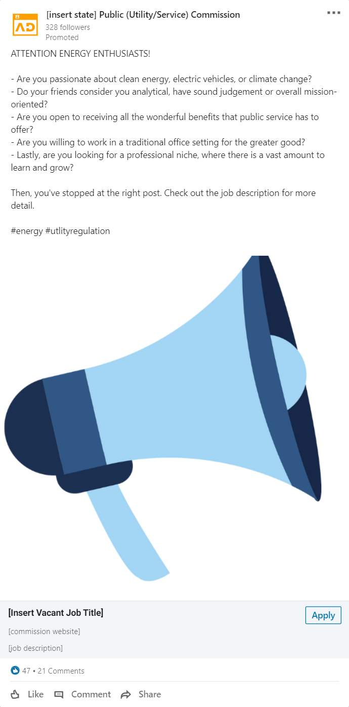
CALL TO ACTION

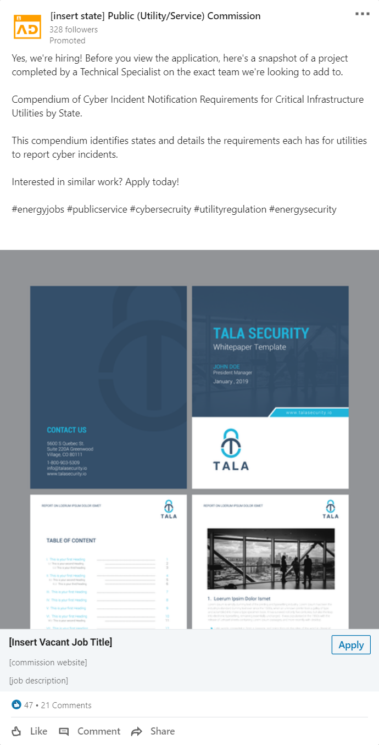

- This specific job highlight will be a “caption” for the job listing.

- Identify a project from a similar role you are looking to hire for.

- Use the appropriate hashtags for the area of work you are looking to fill.

- Consult with your communications team for state and Commission logos and graphics.

SPECIFIC PROJECT HIGHLIGHT
SPECIFIC PROJECT
HIGHLIGHT

Social Media Engagement: Instagram

Instagram is another great example of a social media platform that can give a clear indication of who a company/organization is and a view into the values they promote.
The following template in this section is:
- Staff Spotlight
  - A creative way to showcase your existing talent and give a sneak peek for the potential candidate to see their future co-workers, adding a personal element beyond the job description and Commission website.

IMPORTANT: These are strictly templates that cannot be edited. Follow the copyright tips to create an exact replica of the template on Instagram, or any other social media platform of your preference.

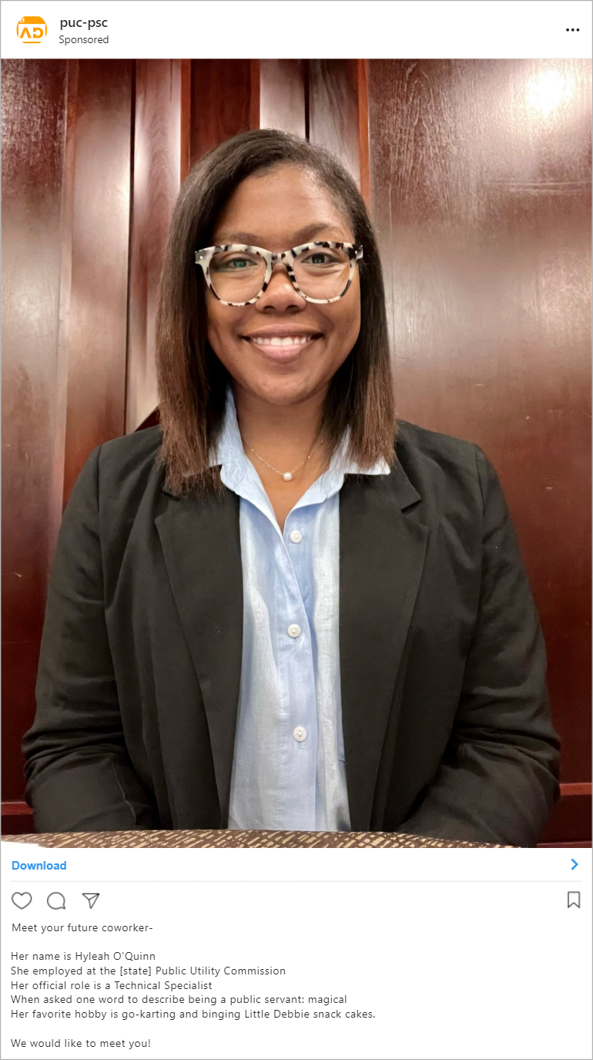

- Highly suggest using the caption format of:

- Name
- Name of Commission
- Position
- A Q& A about Public Service
- Fav Food, Hobby, etc.

- Adding hashtags related to the area of work can help boost traffic to the post.

STAFF SPOTLIGHT

Social Media Engagement: Twitter

Twitter allows a unique level of interaction between users and companies or organizations, while being formal and fun at the same time. Like other social platforms, Twitter can be used to share content about open positions, feature interesting stories about employees and highlight specific benefits in a quick, quirky way.
The following template in this section is:
- Specific Benefit Highlight
  - A complimentary way to showcase a unique or highly favourable benefit from the Commission as a way to drive traffic to your website or job opening page.

IMPORTANT: These are strictly templates that cannot be edited. Follow the copyright tips to create an exact replica of the template on Twitter, or any other social media platform of your preference.

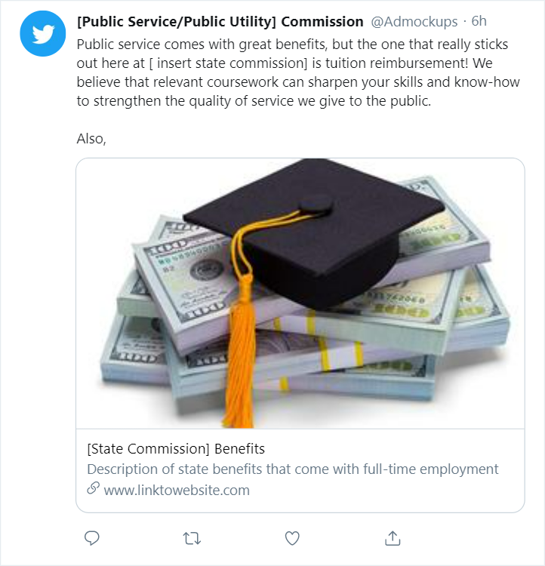
SPECIFIC BENEFIT HIGHLIGHT

- Identify a benefit that is unique to your commission and/or is a very popular amongst employees.

- Adding hashtags related to the area of work can help boost traffic to the tweet.

- Fun, witty, and quirky language usually resonates well with the audience.

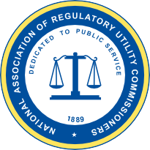

National Association of Regulatory Utility Commissioners

1101 Vermont Ave, NW • Suite 200 • Washington, DC 20005
www.naruc.org • (202) 898-2200

